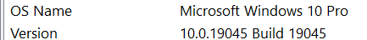
8 Core(s), 8 Logical Processor(s)

